**AWS RDS Multi-AZ vs Read Replica**

[[](https://www.linkedin.com/in/pavan-pusuluri-03871021/)](https://www.linkedin.com/in/pavan-pusuluri-03871021/)

**[Pavan Pusuluri](https://www.linkedin.com/in/pavan-pusuluri-03871021/)**

Sr. Database Consultant | Database Migration Specialist | Database Solution Architect | AWS | Azure

[5 articles](https://www.linkedin.com/in/pavan-pusuluri-03871021/recent-activity/posts/)Follow

October 21, 2021

Often, i have been asked by my customers on the differences between RDS multi-AZ vs Read Replica . Well, Multi-AZ and Read Replica both have another database instance sitting in a separate AZ and in some sense, the Read Replicas seem to be “multi-AZ” because of that. This may be confusing to some, as it appears that both designs functions the same way.

Well, actually that is not the case.

**Multi-AZ Deployment**

In a Multi-AZ deployment, the data is replicated **SYNCHRONOUSLY** – all your instances have the same data at any given time. It is a feature that is used to help with **resilience** and **business continuity**. RDS uses a Failover mechanism on Oracle,MySQL,Maria DB and PostgreSQL instances.

Another difference is that you cannot use a Standby instance in a Multi-AZ design to serve read traffic as it is only used for failover. Therefore, the Multi-AZ deployment is not a read-scaling solution. If you need to serve or offload read traffic, you’ll need to use a read replica instead.

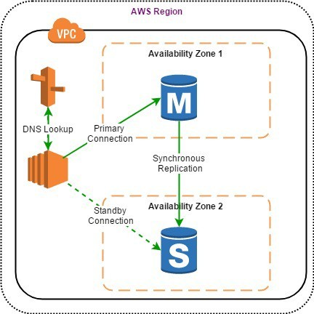

**Multi-AZ Use Cases**

* To get high availability, and enhance availability during planned system maintenance, and help protect databases against DB instance failure and Availability Zone disruption.
* To get data redundancy, eliminate I/O freezes, and minimize latency spikes during system backups.
* Multi-AZ makes maintenance easy.

**READ REPLICAS**

Amazon RDS Read Replicas enable you to create one or more read-only copies of your database instance within the same AWS Region or in a different AWS Region to increase the scalability. Updates made to source database are then **ASYNCHRONOUSLY** copied to Read Replicas. Writes can happen in main database only and reads can happen in Read replica database.

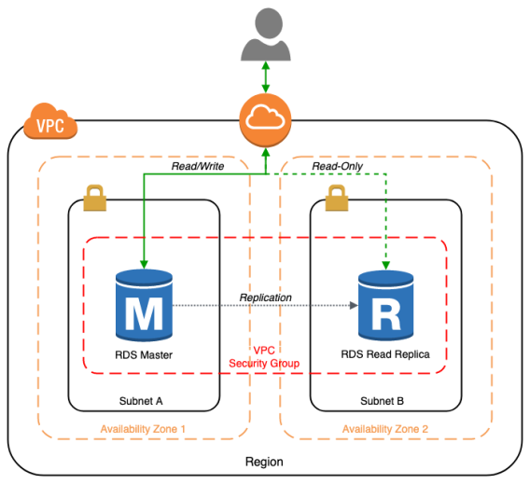

Read replicas are NOT used for resiliency or as secondary instance in the event of a failover.

**Read Replicas Use Cases**

* Business reporting or data warehousing scenarios where you might want business reporting queries to run against a read replica, rather than your production DB instance.
* Implementing disaster recovery. You can promote a read replica to a standalone instance as a disaster recovery solution if the primary DB instance fails.
* Scaling beyond the compute or I/O capacity of a single DB instance for read-heavy database workloads. You can direct this excess read traffic to one or more read replicas.
* Serving read traffic while the source DB instance is unavailable. In some cases, source DB instance might not be able to take I/O requests, for example due to I/O suspension for backups or scheduled maintenance. In these cases, you can direct read traffic to your read replicas.

**Summary**

If you need to design a solution where you are focused on **SCALABILITY**(you need to scale the reads and decrease load on the primary instance), you should look into implementing read replicas. Amazon RDS can support up to 5 read replicas per database instance (for MySQL, MariaDB, PostgreSQL, Oracle and SQL Server). If you need to implement a design where AVAILABILITY is the main concern, you should consider using a Multi-AZ deployment.

You can use Read Replicas with Multi-AZ as part of a **DISASTER RECOVERY**(DR) strategy for your production databases. A well-designed and tested DR plan is critical for maintaining business continuity after a disaster. A Read Replica in a different region than the source database can be used as a standby database and promoted to become the new production database in case of a regional disruption.